Why Choose Communiqué for Your Hearing Care?
We don't just fit a hearing aid. We measure, personalise, verify, train and follow up.
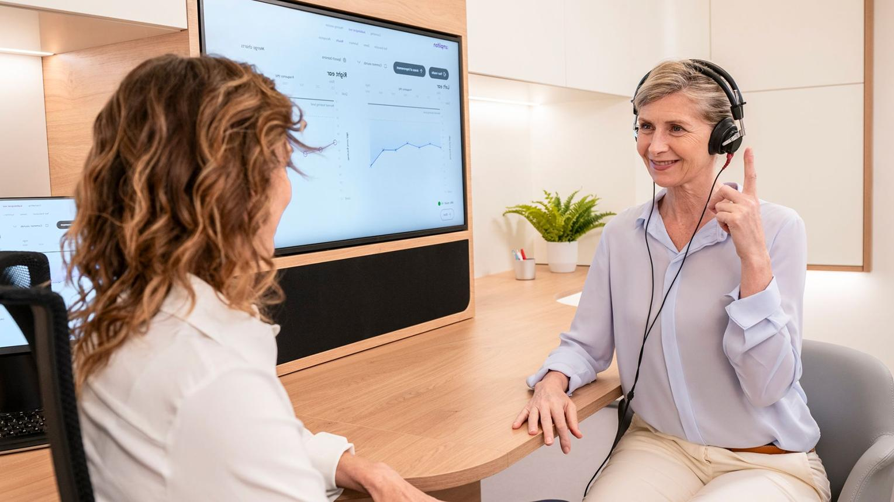
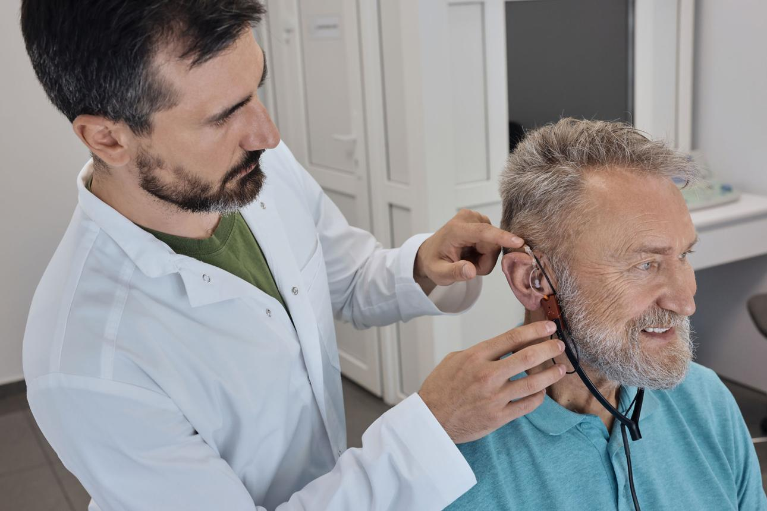

4
1. Start with TRUST — before talking about technology
Your first section should establish who is looking after the patient.
Experienced Clinical Expertise
- M.Aud. & BASLP from AIISH, Mysore
- Clinical experience at Army Hospital (R&R), New Delhi
- Comprehensive audiological assessment before amplification
- Evidence-based hearing-aid selection and fitting
- Long-term rehabilitation and follow-up
I would avoid saying “One of the best audiologists” on the website. It's a claim that sounds promotional and is difficult to substantiate.
Instead say:
“Specialist Audiological Care Backed by Advanced Training & Clinical Experience”
That sounds more premium and credible.

2. Your strongest differentiator: Assessment before amplification
This should be one of your biggest selling points.
We don't recommend a hearing aid based on an audiogram alone.
Your proposed assessment is excellent.
I'd structure it into four levels so patients don't feel they're reading a laboratory test menu.
🦻 Hearing Sensitivity
- Pure Tone Audiometry
- Speech Audiometry
- Tympanometry
- Acoustic Reflexes
🗣️ Speech & Communication
- Speech Recognition
- Speech Understanding in Noise
- Functional listening assessment
🧠 Advanced Auditory Assessment
Where clinically indicated:
- OAE
- BERA/ABR
- LLR
- Special tests for cochlear/retrocochlear involvement
👤 Lifestyle & Communication Assessment
- Listening environments
- Communication partners
- Occupational requirements
- TV/music preferences
- Smartphone requirements
- Social activities
- Dexterity
- Cosmetic preferences
- Expectations
This creates a powerful message:
“We don't just ask how much you can hear. We assess how hearing loss is affecting your life.”

3. Make Speech-in-Noise testing a HERO feature
This is something I'd promote heavily.
A patient might say:
“Doctor, I can hear people. I just can't understand them in noise.”
That's an extremely relatable problem.
Your website can have a section:
Can You Hear Speech But Still Struggle in Noise?


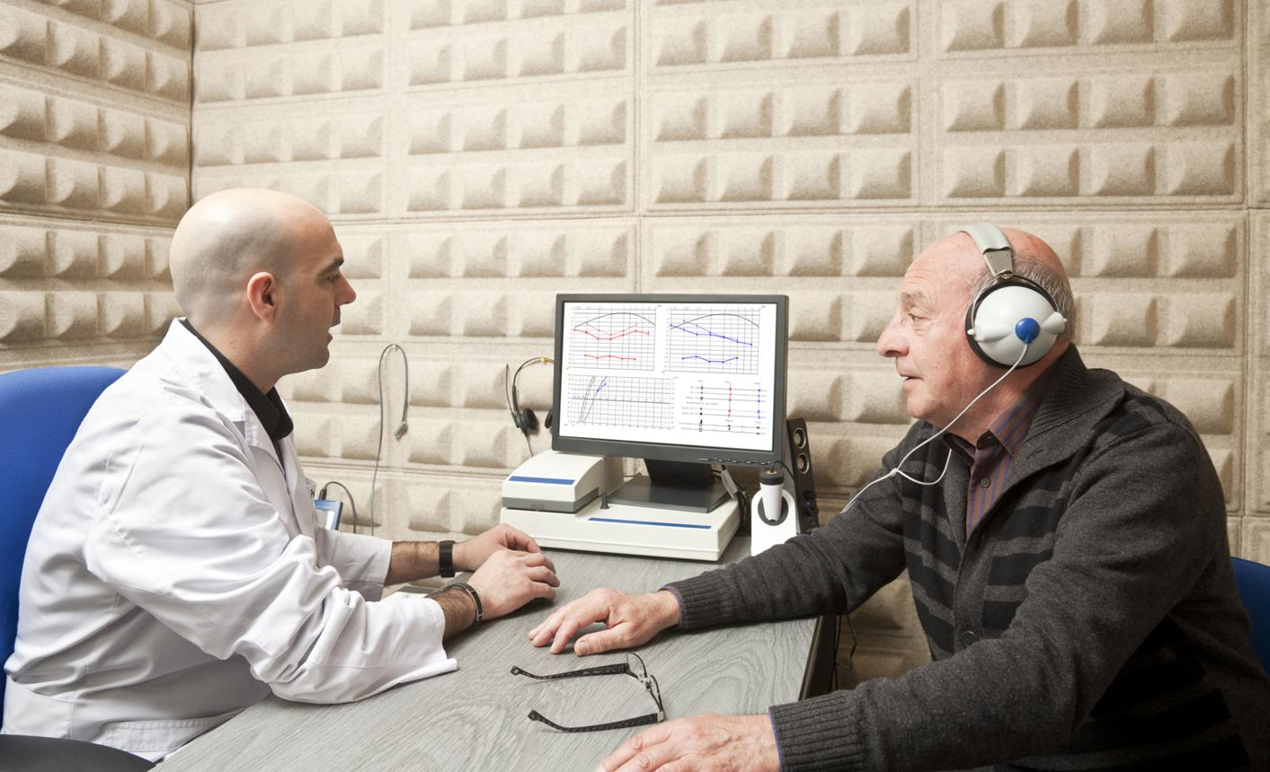
5
We assess more than your hearing thresholds.
Depending on the clinical requirement, your assessment may include speech understanding in challenging listening conditions.
This helps us understand difficulties that may not be fully represented by a conventional pure-tone audiogram.
That information can help guide:
Hearing-aid technology selection → counselling → programming → rehabilitation
This is a much better differentiator than saying “advanced equipment.”

4. Your "Real-World Hearing Aid Experience" can become your signature feature
This is probably your best marketing idea.
Most clinics say:
Free hearing aid trial.
You can say:
Experience Your Hearing Aid in Real-World Listening Situations



4
Instead of simply putting the hearing aid on and asking:
"Can you hear better?"
you demonstrate situations relevant to the patient's life.
👥 One-to-One Conversation
Can you understand a person sitting across from you?
👨‍👩‍👧 Group Conversation
Can you follow several people talking?
🔊 Noisy Environment
How does speech sound when background noise is present?
🌳 Environmental Sounds
Can you comfortably perceive everyday sounds?
📺 Television
Can you follow dialogue without excessively increasing the volume?
🎵 Music
How natural and comfortable does music sound?
📍 Distant Speech
How well can you access speech from a distance?
And I'd add two more:
🚶 Movement
How does speech sound while walking or moving around?
📱 Smartphone/Connectivity
If applicable, how does streamed phone audio or Bluetooth connectivity work?

5. Add "Before vs After" objective measurement
This can make Communiqué look significantly more sophisticated.
Don't only say:
"Patients tell us they hear better."
Measure it.
For appropriate patients, you can document:
BEFORE
- Hearing thresholds
- Speech recognition
- Speech-in-noise performance where applicable
- Patient-reported communication difficulty
- Hearing Handicap/quality-of-life questionnaire
AFTER
- Hearing-aid aided performance where clinically appropriate
- Speech understanding
- Patient-reported benefit
- Listening confidence
- Quality-of-life measures
Then show:
Your hearing-aid journey is measured—not guessed.
This is powerful.

6. Your follow-up system is excellent — make it visible
This is another thing that can differentiate you from a hearing-aid retailer.
Your hearing journey doesn't end when you purchase the device.
Follow-up programme
Initial fitting
↓
1 week
↓
2 weeks
↓
1 month
↓
3 months
↓
Every 6 months
At follow-ups:
- Listening experience
- Comfort
- Speech understanding
- Noise performance
- Device handling
- Battery/rechargeable performance
- Lifestyle changes
- Patient concerns
- Questionnaire-based outcomes
- Fine-tuning when required
I'd call this:
Communiqué Hearing Success Programme™
You don't need to make it sound like a warranty.
It's a care pathway.

7. Auditory rehabilitation should become another signature feature
This is something I would strongly emphasize.
A hearing aid provides access to sound. Rehabilitation helps you make the most of that access.
Depending on individual needs, auditory rehabilitation may address:
- Speech discrimination
- Auditory attention
- Speech understanding
- Listening in noise
- Auditory memory
- Sound identification
- Communication strategies
- Conversation repair
- Adapting to amplified sound
And your phrase about neuroplasticity is good, but I would phrase it carefully:
“Structured auditory rehabilitation can help patients adapt to amplified sound and make better use of auditory information through learning and neural adaptation.”
That's more scientifically defensible than promising that auditory training will automatically "unlock brain neuroplasticity."

8. Add something competitors usually don't communicate strongly: Expectation counselling
This can massively improve trust.
We tell you what a hearing aid can—and cannot—do.
Before fitting, explain:
- What improvement is realistic
- What situations may remain challenging
- Why background noise is difficult
- Why adaptation takes time
- Why consistent use matters
- Why follow-up programming is important
- Whether one or two hearing aids may be appropriate
- What technology level is actually necessary
This gives the patient the feeling:
"They are not just trying to sell me the most expensive device."
That perception is incredibly valuable.

9. Introduce a "Good–Better–Best" recommendation
Technology Level | Indicative Price Range* | Best Suited For | Typical Features
Essential | ₹30,000 – ₹85,000 | People who primarily communicate in quiet environments and have relatively straightforward listening needs | Essential sound processing, directional microphones, basic noise management, rechargeable options on selected models
Standard | ₹85,000 – ₹1,50,000 | Daily wear, family conversations, television, moderate background noise and regular social situations | Improved noise management, directionality, feedback management, connectivity and rechargeable options on selected models
Advanced | ₹1,50,000 – ₹2,50,000 | Active users who frequently communicate in restaurants, groups, meetings and other challenging listening environments | More advanced noise management, speech enhancement, adaptive directionality, environmental analysis and enhanced connectivity
Premium | ₹2,75,000 – ₹4,50,000+ | Highly active users who regularly encounter complex listening environments and want the highest available level of processing and connectivity | Advanced speech-in-noise processing, sophisticated environmental adaptation, premium connectivity and additional intelligent processing features

10. Add a "Why this hearing aid?" report
This could be one of your strongest innovations.
After assessment, give the patient a simple one-page:
Your Personalised Hearing-Aid Recommendation
Your hearing profile
Right ear: ___
Left ear: ___
Your biggest communication difficulties
☑ TV
☑ Group conversations
☑ Background noise
☑ Telephone
☑ Distance
☑ Family conversations
Recommended hearing-aid style
RIC
Recommended technology level
Advanced
Why?
"Selected because you frequently participate in group conversations and experience difficulty understanding speech in background noise."
Alternatives considered
Essential / Advanced / Premium
Recommended trial
Yes
This transforms the consultation from:
"Doctor is trying to sell me a hearing aid"
into:
"Doctor has created a treatment recommendation for me."

11. Add a "No pressure" promise
This is surprisingly powerful.
No-pressure hearing-aid consultation
You are encouraged to ask questions, compare options and experience the technology before making a decision.
Don't say:
"We don't force you to buy."
That sounds defensive.
Instead:
"Our goal is to help you make an informed decision."
Much more premium.

12. Give patients a hearing-aid comparison sheet
When someone is comparing Communiqué with Centre for Hearing / Soft Hear / Priority, don't fight them.
Help them compare.
Give them a checklist:
What should I compare? | Communiqué
Comprehensive hearing assessment | ✓
Speech audiometry | ✓
Speech-in-noise assessment where appropriate | ✓
Lifestyle assessment | ✓
Multiple brands | ✓
Hearing-aid demonstration | ✓
Real-world trial | ✓
Personalised fitting | ✓
Follow-up fine-tuning | ✓
Auditory rehabilitation | ✓
Outcome questionnaires | ✓
Long-term follow-up | ✓
Protection plan | ✓
Then tell the patient:
"When comparing hearing-aid clinics, don't compare only the price of the device. Compare the care included with it."
This is exactly the battle you need to fight.

13. Add a hearing-aid protection plan
You've already thought of this.
Make it concrete.
Instead of simply:
Protection plan available.
Explain what it covers.
For example, depending on your actual commercial terms:
Device care
Cleaning
Periodic checks
Programming adjustments
Priority appointments
Accidental damage options if applicable
Warranty assistance
Don't advertise anything you don't actually provide.
But the concept is excellent because it shifts the patient's thinking from:
"How much does the hearing aid cost?"
to:
"What do I receive over the next few years?"

14. Add home support if commercially feasible
This is something the larger competitors use heavily.
If you can operationally provide it, consider:
Home Hearing Support
For selected elderly patients or patients with mobility difficulties:
- Home hearing counselling
- Device handling education
- Follow-up support
You don't necessarily need to make it free.
Even:
Home visits available on request
adds convenience.

15. Add family counselling
This is very important for hearing aids.
Often the person buying the hearing aid isn't the person who made the decision.
The son/daughter/spouse is.
So:
We involve the family in hearing rehabilitation.
Teach family members:
- Speak clearly rather than shouting
- Face the listener
- Reduce unnecessary background noise
- Get the patient's attention before speaking
- Use visual cues
- Don't repeatedly say "Are you hearing me?"
This makes Communiqué look like a hearing rehabilitation clinic, rather than a hearing-aid shop.

16. Make your location a major advantage
Don't just write:
Located in Sector 113.
Say:
Advanced Hearing Care on Dwarka Expressway
Conveniently located at M3M Market, Sector 113, Gurugram.
For residents of:
Dwarka Expressway | Sector 113 | Sector 112 | Sector 114 | New Gurgaon | nearby communities
you can access comprehensive hearing care without travelling deep into Gurgaon.
I would use the phrase:
"The dedicated hearing-care destination on Dwarka Expressway."
rather than "the only hearing aid clinic" unless you've verified that claim very carefully and are comfortable substantiating it.

17. Your clinic itself should become part of the marketing
You mentioned:
Modern and premium clinic with all advanced instruments and tests.
Don't merely say this.
Show it.
Create a professional video:
"What happens when you visit Communiqué?"
Camera enters clinic.
Reception.
Audiology room.
Audiometer.
Tympanometer.
OAE.
ABR/BERA.
VNG/vHIT.
Hearing aids.
Patient counselling.
Hearing-aid trial.
Follow-up.
The message:
"This isn't a hearing-aid shop. This is a complete hearing and balance clinic."
That distinction matters.

18. I would add a "Meet your Audiologist" video
30–45 seconds.
Not a highly polished advertisement.
You sitting in the clinic:
"Hello, I'm Dr. Saurabh Chitoshiya, Audiologist and Clinical Director at Communiqué. Before recommending a hearing aid, I believe it's important to understand not just how much you can hear, but how hearing loss is affecting your everyday communication..."
Then explain your assessment → trial → fitting → follow-up model.
People buy from people they trust.
Your personal credibility is currently under-utilised.

19. Your final positioning should be this
I'd create a big visual on the website:
The Communiqué Hearing Care Journey
01 — Comprehensive Assessment
↓
02 — Understand Your Lifestyle
↓
03 — Speech & Speech-in-Noise Evaluation
↓
04 — Personalised Recommendation
↓
05 — Real-World Hearing Aid Experience
↓
06 — Precision Fitting
↓
07 — Outcome Measurement
↓
08 — Auditory Rehabilitation
↓
09 — Long-Term Fine-Tuning
↓
Better Hearing. Better Communication. Better Quality of Life.
That is far more powerful than "up to 50% off."

One thing I'd change in your current list
You currently have:
"One of the best audiologists"
I'd remove that.
And I'd replace it with:
"Specialist Audiological Care"
AIISH-trained Audiologist with clinical experience at Army Hospital (R&R), New Delhi.
That's a fact-based trust signal, rather than an advertising claim.
Similarly, instead of:
"Advanced instruments and tests"
say:
"Comprehensive Audiological Assessment"
and actually show the tests.
Instead of:
"Real-world hearing aid experience"
say:
"Experience Your Hearing Aid in the Situations That Matter to You."
And instead of:
"Follow-up"
say:
"A Structured Hearing-Aid Follow-Up Programme."
These small wording changes make the clinic feel much more premium, clinical and trustworthy.

The biggest opportunity for Communiqué
I would build your entire hearing-aid brand around one sentence:
"We don't just help you hear more. We help you hear better."
And underneath:
Comprehensive assessment → Personalised hearing-aid trial → Precision fitting → Real-world verification → Auditory rehabilitation → Long-term follow-up
That is a proposition that Centre for Hearing, Soft Hear and Priority Hearing can all technically offer pieces of, but you can make it the central identity of Communiqué.
And importantly, it gives you a reason for a patient to choose you even when another clinic offers a lower hearing-aid price.

